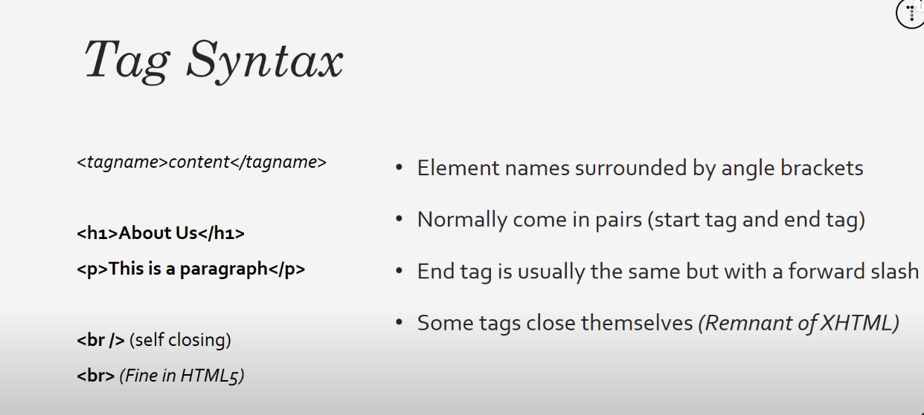

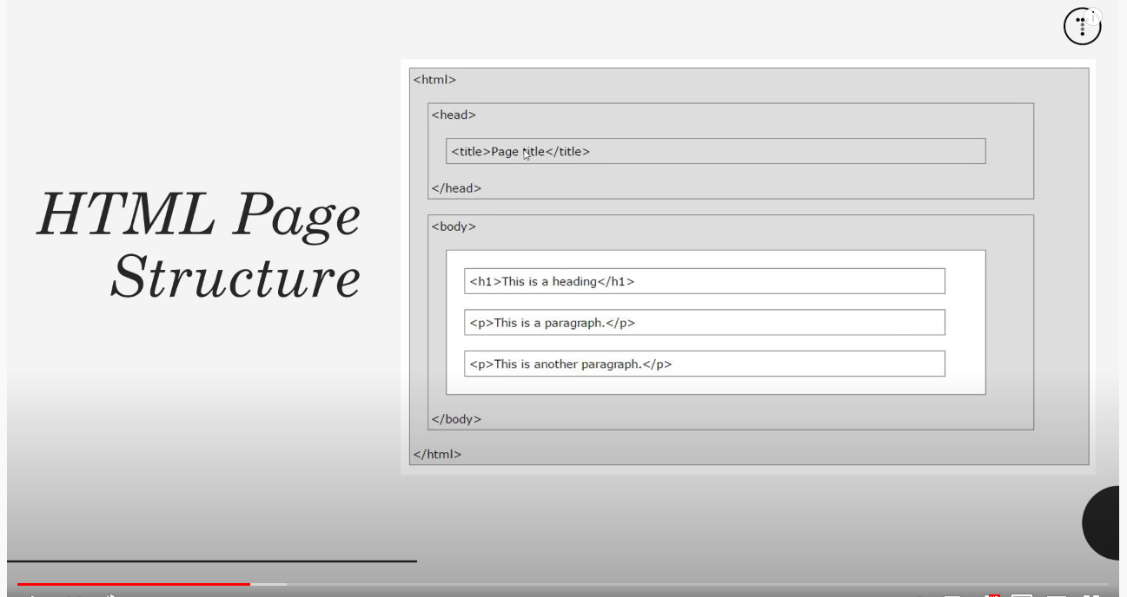

<head> does not have any output holds CSS links & JavaScript file meta data(description and key words)

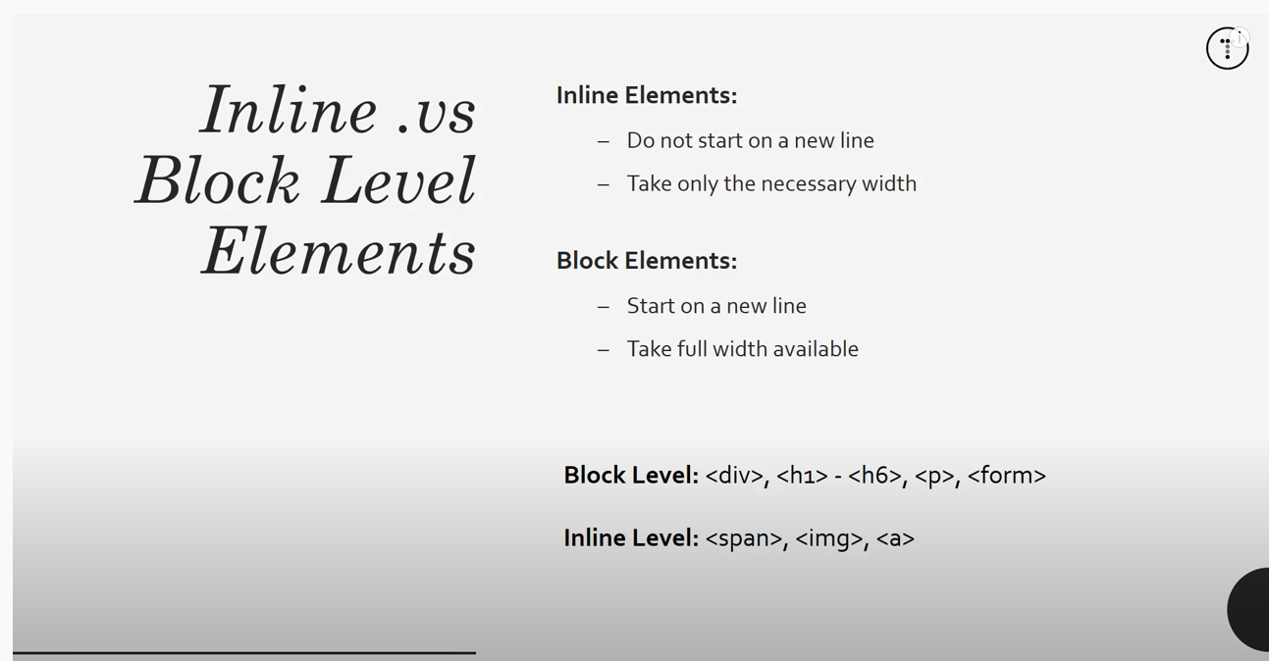

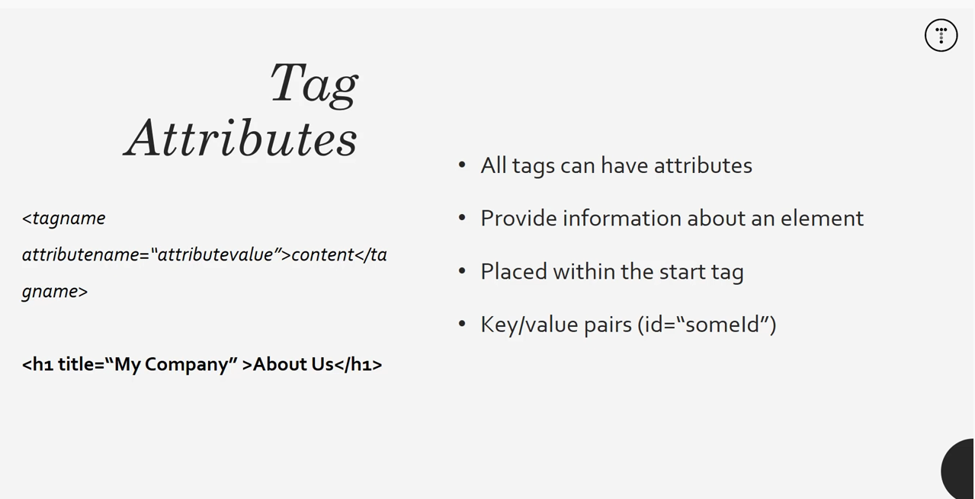

Attributes are always placed at the opening tag

<OL> -- ordered list

Populates with number identifies and basic formatting

<UL> - populates with bullet points and

FORMS -- html creates layout but you need PHP or something else to make them function



References code that makes form function and method tells it what to do with form data that has been gather "post" sends it to a designated database "get" displays the data